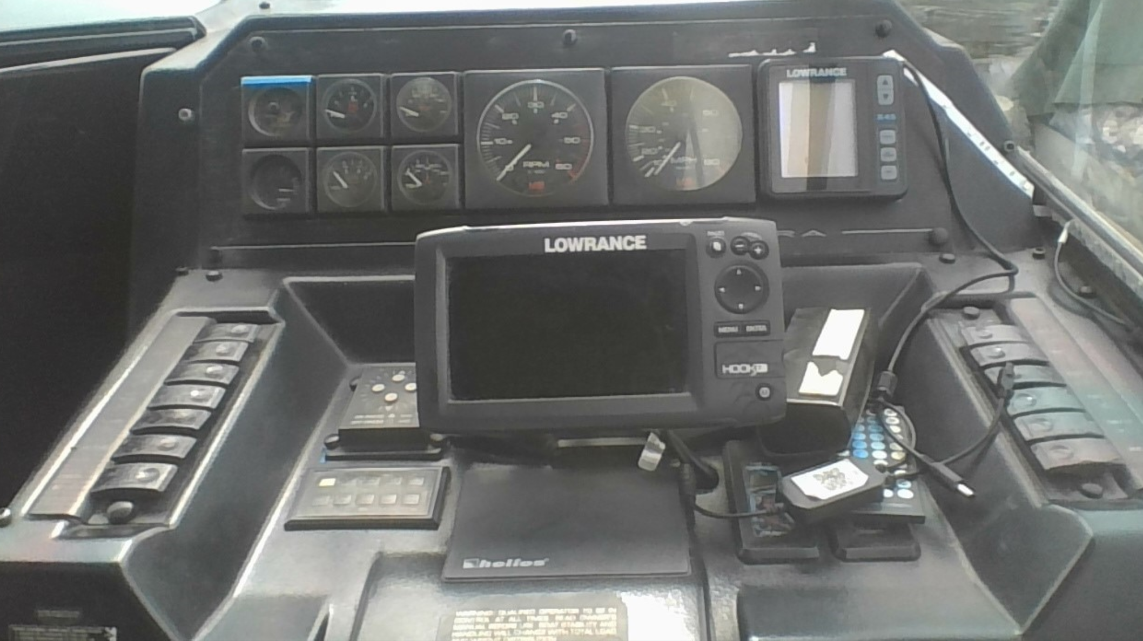



* Check weather: Apps and websites
  + Sail Flow (app): ‘wind map’
  + weather.gc.ca: strait of Georgia / south of Nanaimo forecast
  + Windy
* Navigation – know where you’re going
  + Navionics (app):
    - Consider a separate GPS module to feed the phone
    - Check currents & tides
* Fuel: 1/3 x3
  + I have 380 litre max capacity
  + Full tank avoids condensation inside the fuel tank during winter.
  + Figure how much fuel is burned at speed (that I want to cruise at)
  + Use dipstick to check engine oil before I leave the dock.
  + Google: “how coolant reservoir works”. Use coolant reservoir as a indication whether engine is running too hot.
    - How does the cooling system work – check with engineer
  + Google and research my engine model to prepare for trouble shooting.
  + Macerator shaft (manual turning) if the circuit blows.
  + Switch between house battery and starting battery.
* Starting sequence:
  + BLOWER (beyond important): turn on for 4 minutes.
  + Make sure I have oil pressure once I’ve started the engine.
* Radio:
  + if I want to know commercial fleet traffic it will be channel 12.